**NEW CONTAINER PATENTED**

This new container patented is directed mainly for the shipping business , in order to cover the necessities to have a container which allow to do vertical stacking mixing containers with different length size.

**This new model of container allow to stack vertically on top of one container another one or two containers with half length size , which is a clear advantage over other competitors**. There are different length size shipping containers (10 feet , 20 feet , 24 feet , 30 feet , 35 feet , 40 feet , 45 feet , ….) , but actually is not possible stack vertically on top one container another one or two containers with half length size , which create many restrictions and problems when the containers must be stacked vertically on a container vessel or in the yard´s terminal in the ports , doing they can´t use the full capacity and space that theoretically they have.

**Actually the terminals in the ports and the container vessels have serious limitations due this restriction when they must stack vertically the containers , and this restriction cause they can´t use the full capacity of the terminals or the container vessels which affect directly to the cost of these companies losing millions $ yearly due they can´t use the real space and capacity they have.**

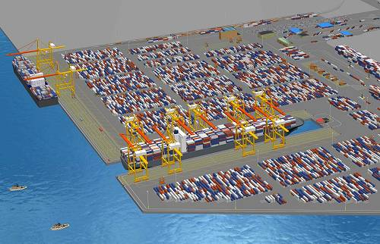

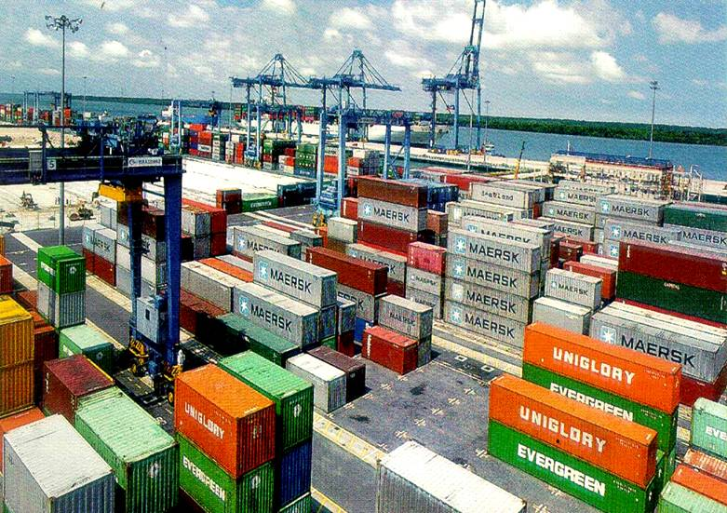

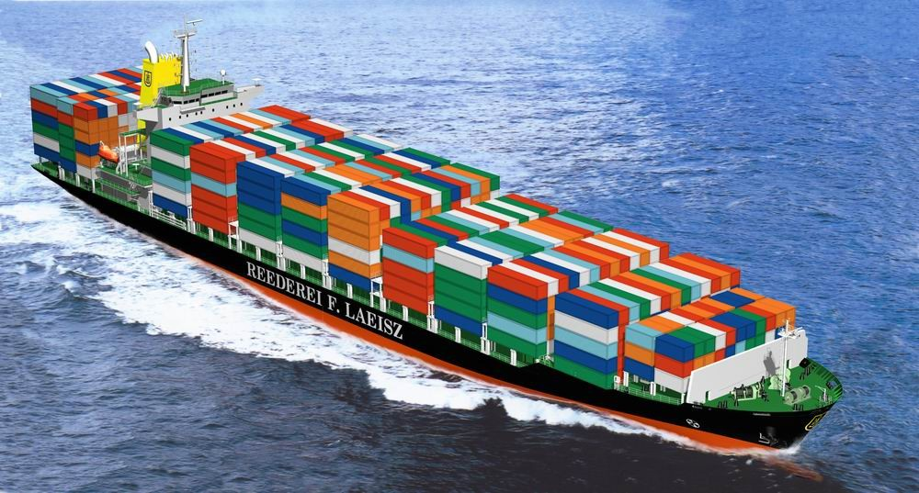

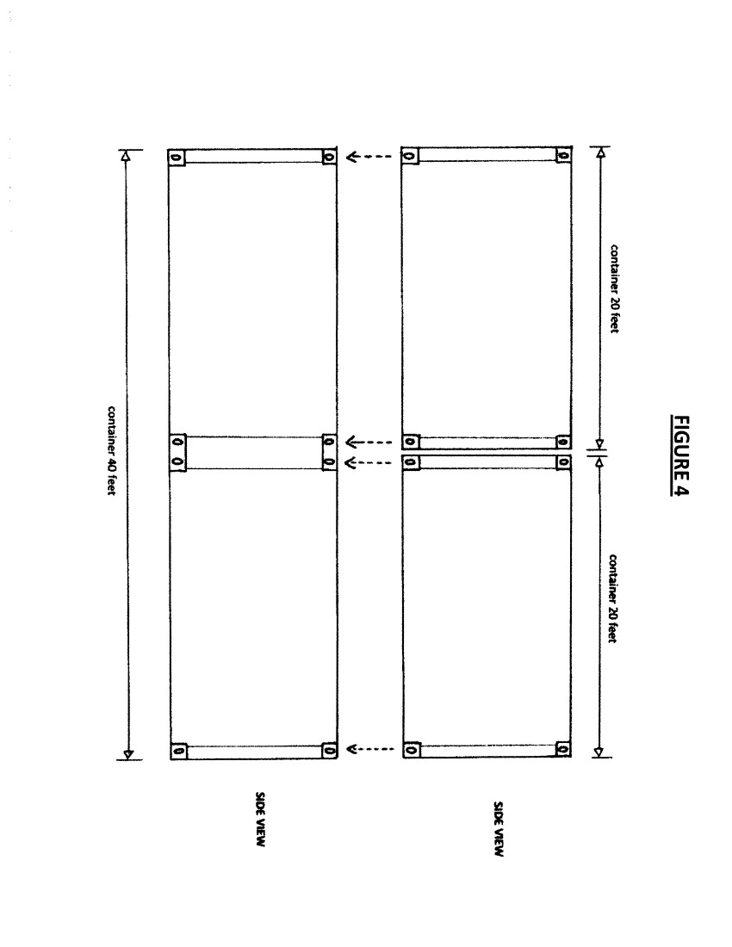**With this new container patented the terminals in the ports and the container vessels could stack vertically by example on top of one container 40 feet another one or two containers 20 feet , and additionally to fix each other using twistlocks in case needed, which will eliminate important restrictions that container vessels and terminals of the ports have actually to stack vertically containers with different length sizes , saving space which means saving millions $ yearly. With this new possibility to mix 20´and 40´without any limitation these companies will optimize as maximum possible the space and capacity they have in their terminals and vessels which automatically will generate important increases in their profits.**

This new container patented is a similar as the containers used actually but with the particularity to have a reinforced vertical bar all around the container in the middle of the length of the container , and with the respective angles casting with holes to allow stack vertically and fix using in case needed twistlocks or another fixing tool.



This can be applied for all the different length size of containers existing actually (10 feet , 20 feet , 24 feet , 30 feet , 35 feet , 40 feet , 45 feet , ….) , but the most clear example to see the great advantage this new container patented has is that allow to stack vertically two containers 20 feet on a container 40 feet which is not possible actually and will suppose a great advantage over other competitors , due with this advantage will not exist anymore limitations to mix vertically 20´and 40´ , which is actually the main problem the yard´s terminals in the ports and the container vessels have to use fully and properly the capacity they have.

**Is very important to consider too that this patent actually is valid for all Chinese territory and additionally I have by law the priority to patent too in rest of countries , so who buy this patent actually valid for China will buy the possibility to do valid this patent too in other countries.**

**Elena Corina Diaconu Moise**

[**cesarcorinayasmin@hotmail.com**](mailto:cesarcorinayasmin@hotmail.com)